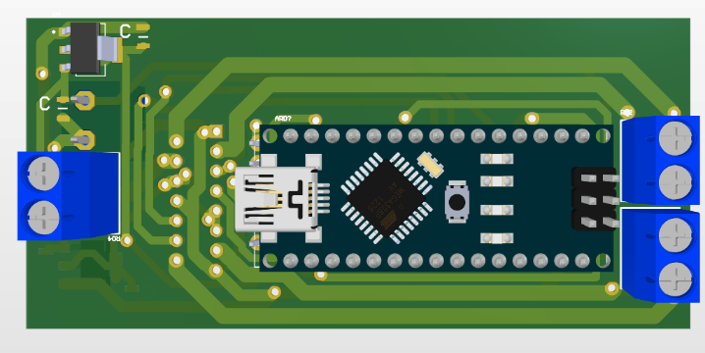
hardware float
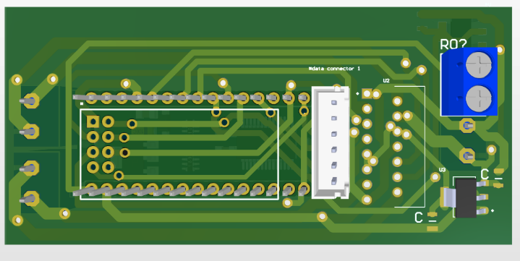
we used Arduino nano as its compact size to achieve the most suitable design for the float And we use pressure sensor bmp280 to know the deep of the float And The input power is supplied by alkaline 9V batteries, to power the Arduino and regulator AMS1117 3.3v to power the and pressure sensor ,NRF module and another one of 5v to power the Arduino nano and we used driver L298N and it will be able to provide the need power the dc motor used
Figure 1 top view

Component | Input Voltage | Max Current | Quantity | Consumed Power
DC Motor | 9v | 500mA | 1 | 4500mW
NRF | 3.3v | 12.3mA | 1 | 40.59mW
nano | 9v | 40mA | 1 | 360mW
Driver L298N | 5v | 36mA | 1 | 180mW
Pressure sensor | 3.3v | 1.120 mA | 1 | 3.696mW
Float Power Calculations
Figure 2 bottom view

